**Truffle development environment**

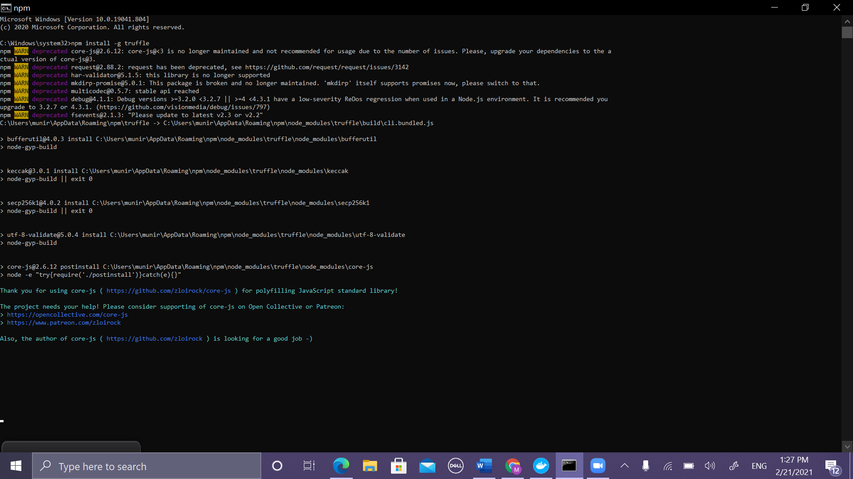**Figure 1 to install truffle write npm install -g truffle**

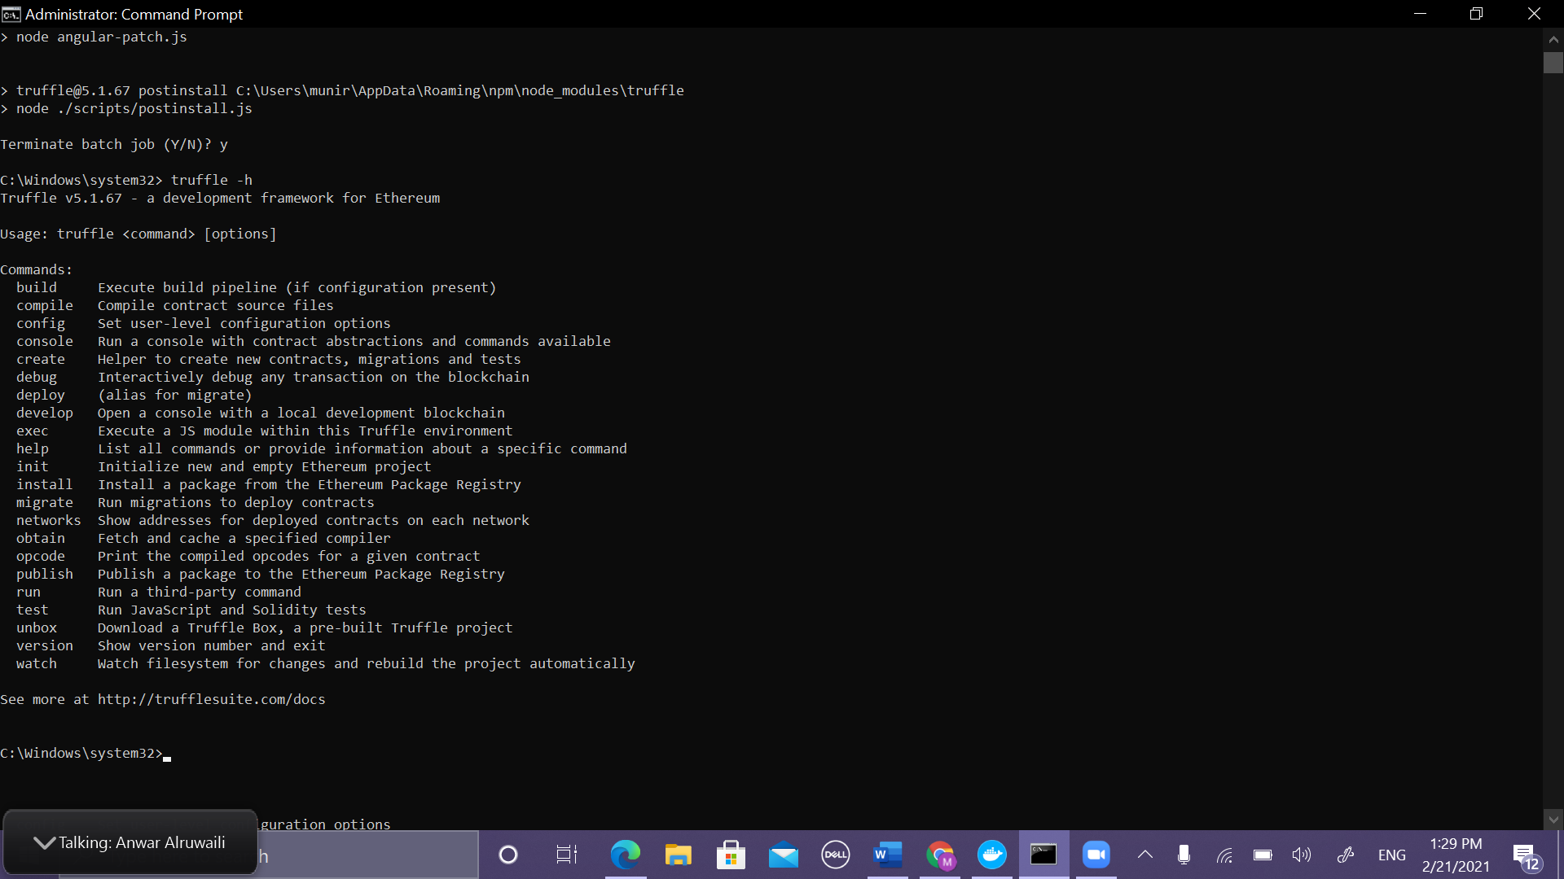

**Figure 2 Run truffle -h to list all commands**

#### How to use Infura in Web3, first need to sign up in Infura

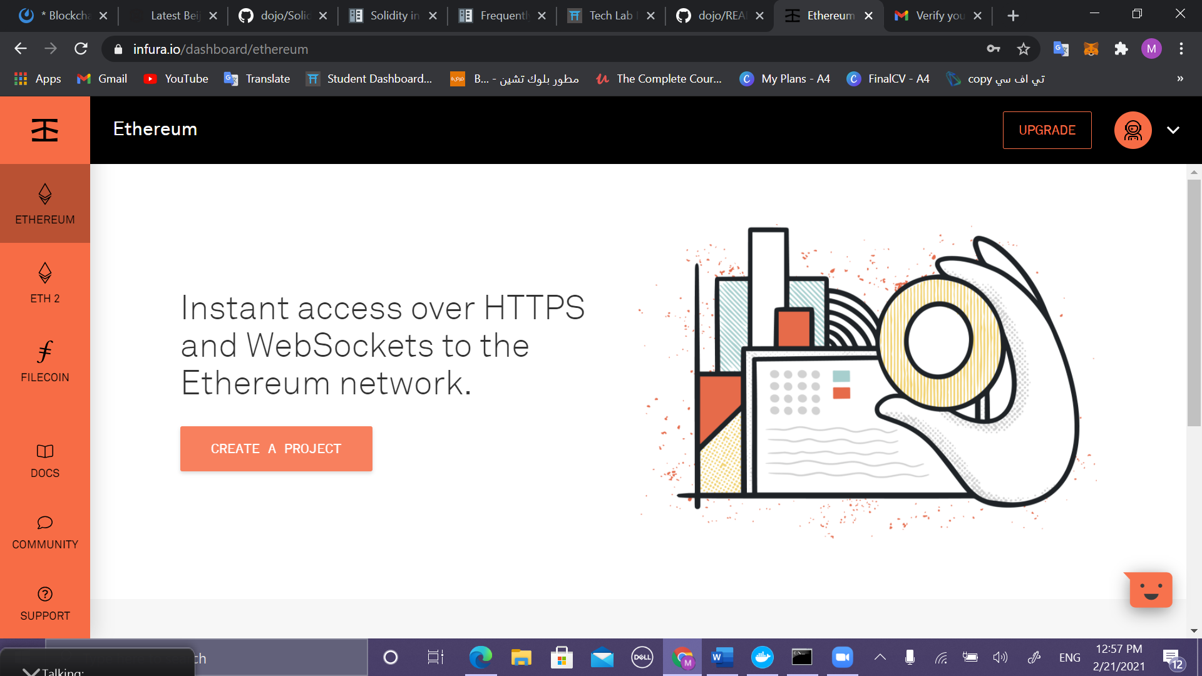

**Figure 3 Click Ethereum then create a project**

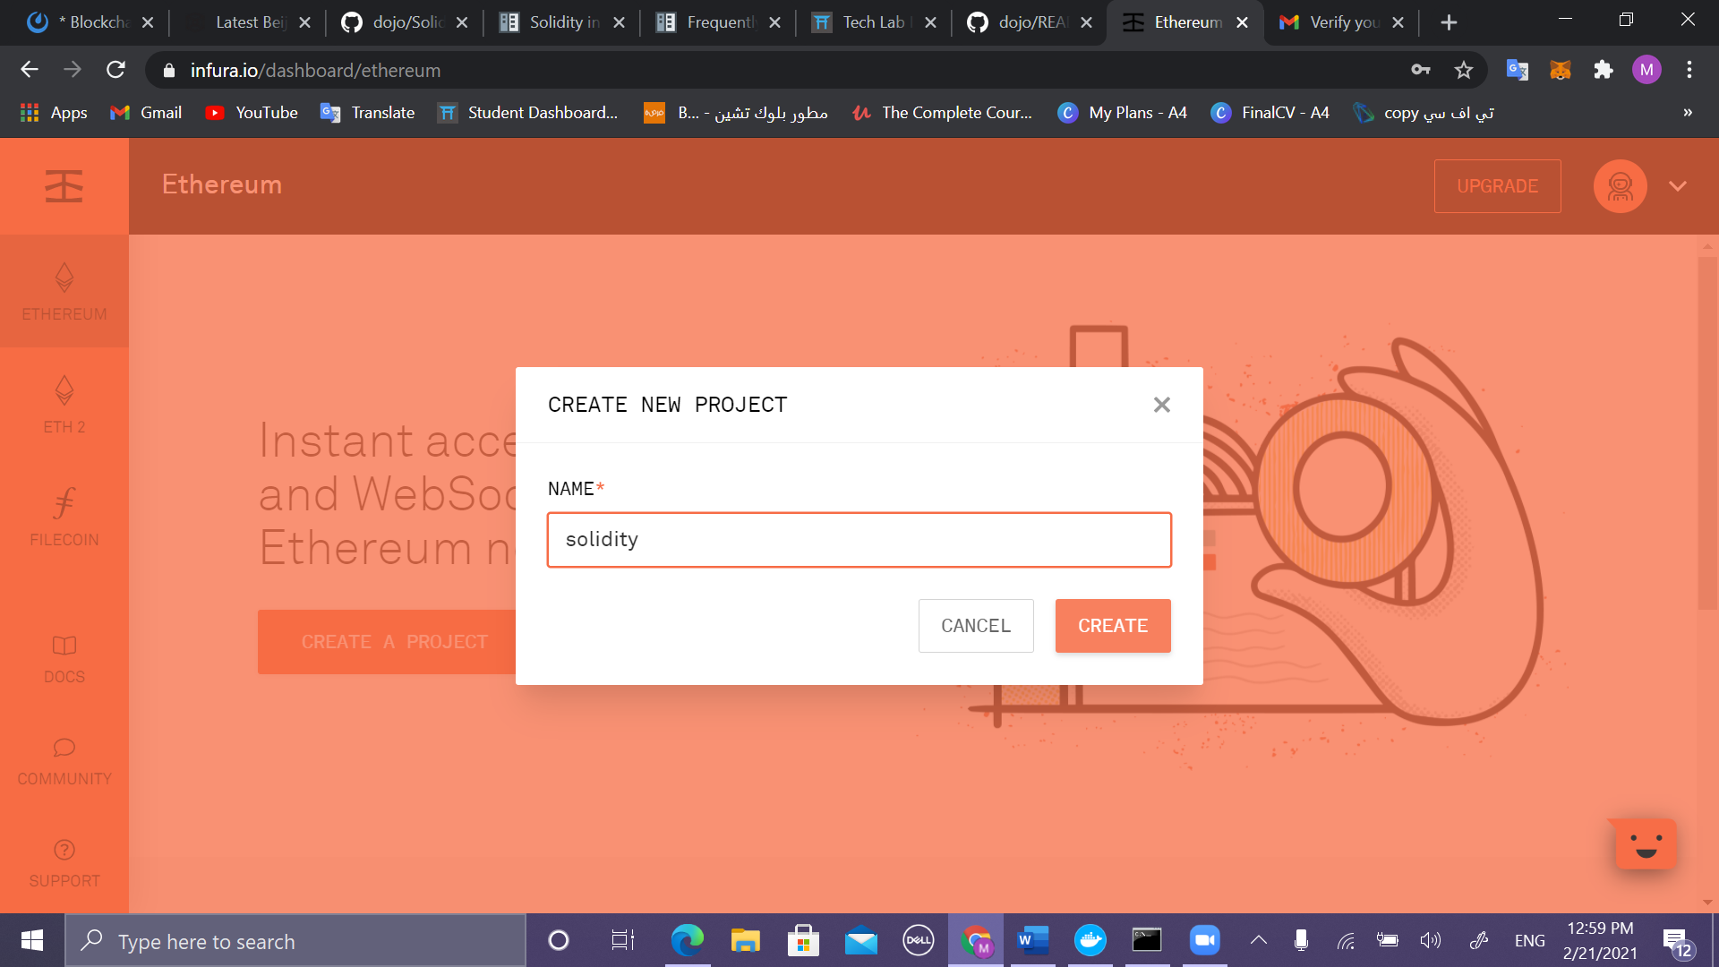

**Figure 4 name my project(solidity)**

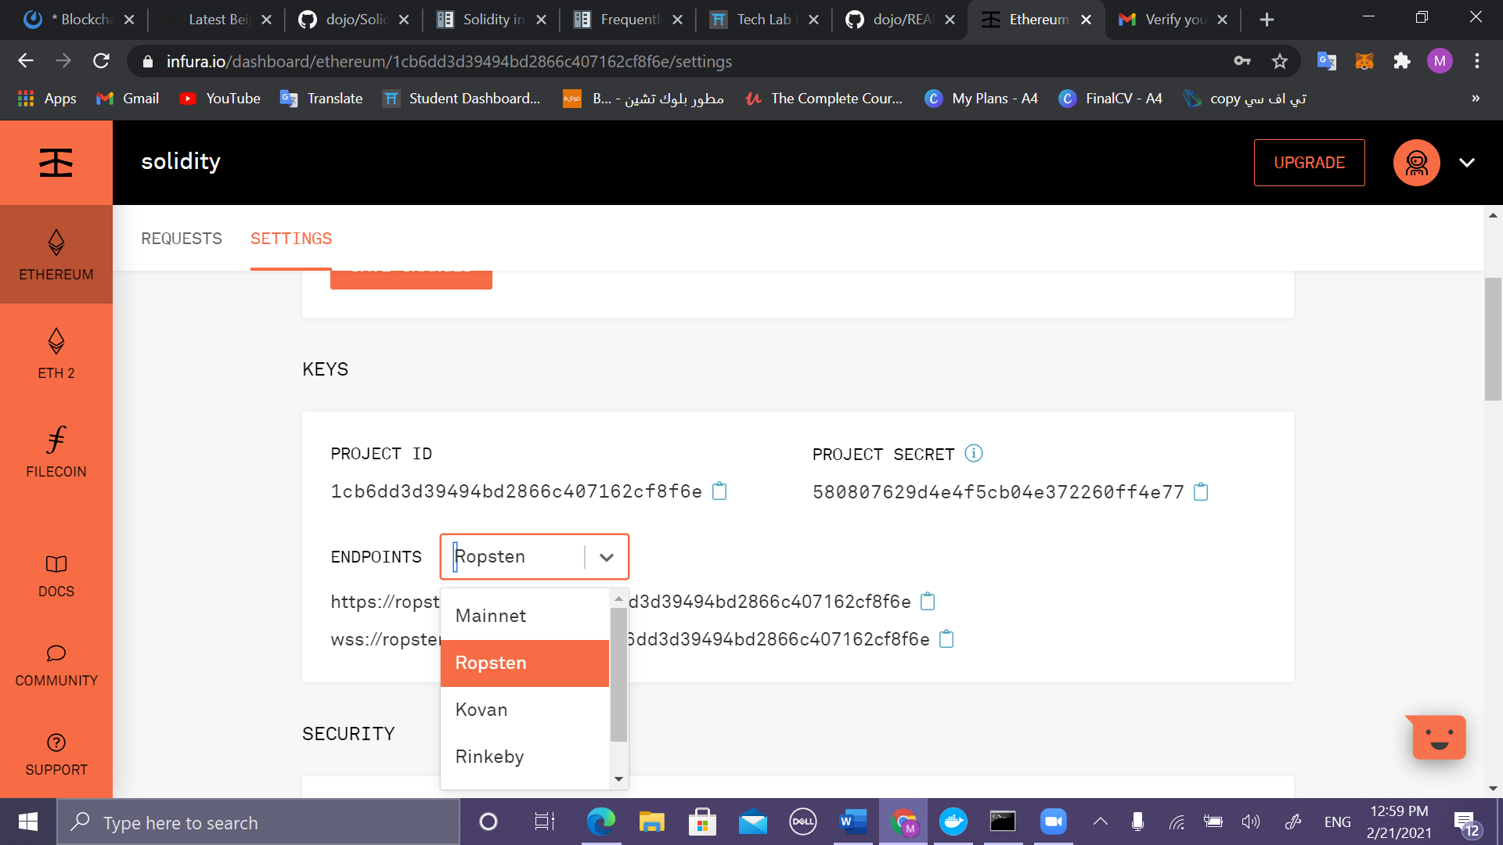

**Figure 5 Change endpoint network to Ropsten**

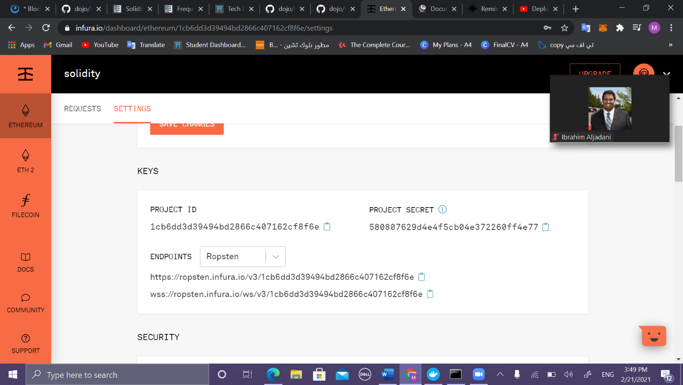

**Figure 6 copy the URL (https://ropsten.infura.io/v3/1cb6dd3d39494bd2866c407162cf8f6e)**

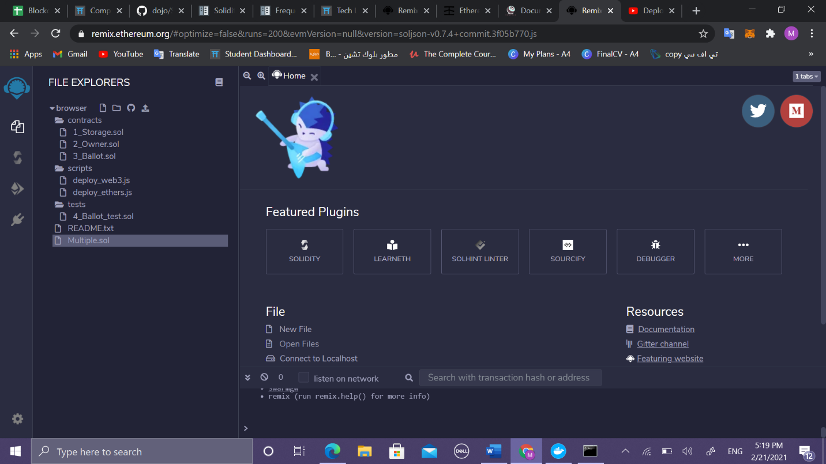Remix  <https://remix.ethereum.org/>

**Figure 7 click on new file and name it with extension(sol)**

#### 

**Figure 8 ensure that solidity compiler is active**

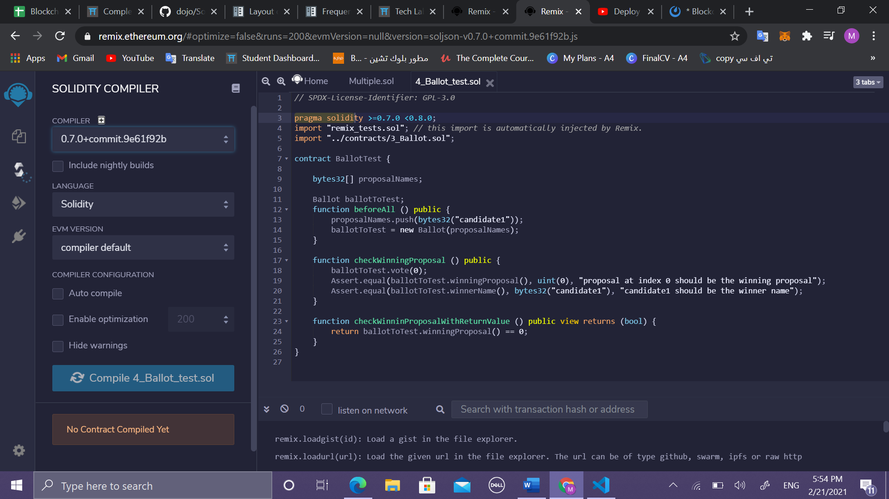

**Figure 9 ensure is the same**

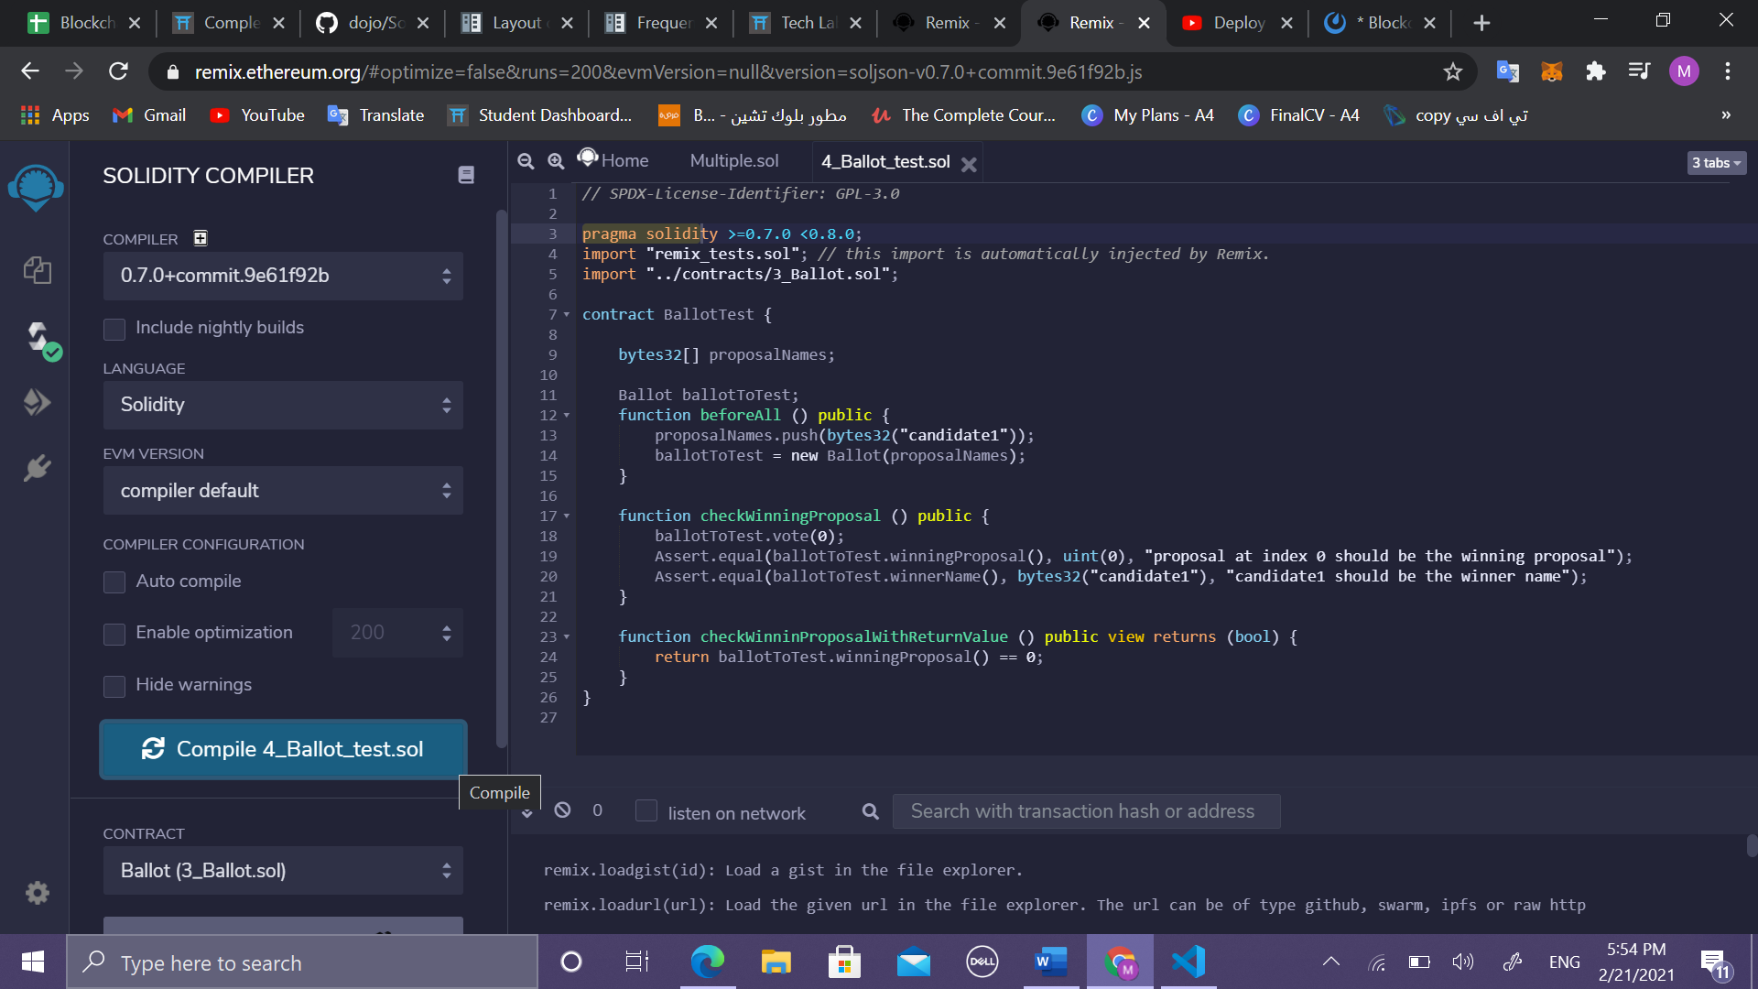

**Figure 10 click on compile**

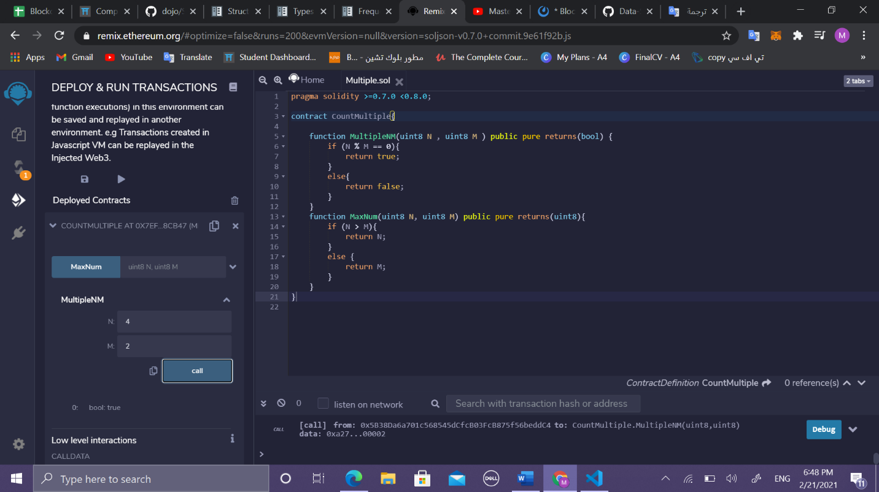-Complete a short solidity function, is Multiple(nm), that takes two integer values and returns True if n is a multiple of m, and False otherwise.

Code for check if N is multiple of M

-Complete a short solidity function takes two integer values and returns the maximum element between two integers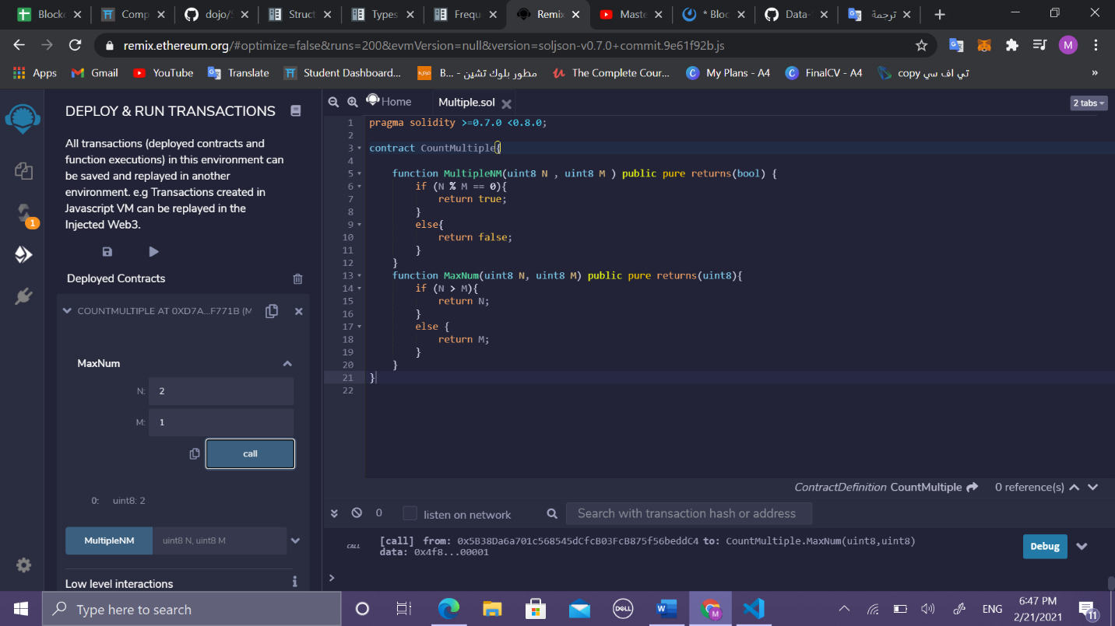

Code for check MaxNum